

Policy for the
Safeguarding of
Children, Young People and Vulnerable Adults

September 2025

This policy is to be read in conjunction with:
“The Church of England; Parish Safeguarding Handbook- Promoting a Safer
Church” (June 2018)
“Promoting A Safer Church; House of Bishops Policy Statement” (2017).
“Safeguarding e-manual” Church of England (2021)

This policy is for the use of St Francis, St Lawrence and Hope Churches, Salisbury.

Agreed by St Francis PCC: 18th September 2025
Reviewed: August 2025
For review: August 2026

POLICY FOR THE SAFEGUARDING OF
CHILDREN, YOUNG PEOPLE AND VULNERABLE ADULTS

RATIONALE
- “The care and protection of children, young people and vulnerable adults involved in Church activities is the responsibility of the whole Church. Everyone who participates in the life of the Church has a role to play in promoting a safer Church for all.” (from “Promoting A Safer Church” 2017). In law, a “child” is an individual aged 17 or under: a “young person” is someone aged 14-17 years. A “vulnerable adult” is a person aged 18 or over whose ability to protect himself or herself from violence, abuse, neglect or exploitation is significantly impaired through physical or mental disability or illness, old age, emotional fragility or distress.

It is important that safeguarding is seen in broad terms that extend beyond abuse-related concerns. As such, “safeguarding” can be understood as “acting in ways that mitigate any risk of harm”. There may be concerns about the safety and wellbeing of an individual which are not linked to abuse by another but are still on the safeguarding continuum. Safeguarding is as much about prevention as reaction and so also covers the risk assessment of environment and activities, anything that will help contribute to keeping people safe.

- In accordance with the Church of England Safeguarding Policy Statement, St Francis, Hope and St Lawrence Churches are committed to:
  - Promoting a safer environment and culture.
  - Safely recruiting and supporting all those with any responsibility related to children, young people and vulnerable adults within the Church.
  - Responding promptly to every safeguarding concern or allegation.
  - Caring pastorally for victims/survivors of abuse and other affected persons.
  - Caring pastorally for those who are the subject of concerns or allegations of abuse and other affected persons.
  - Responding to those who may pose a present risk to others.

SAFER RECRUITMENT
- The Churches will select and vet all those with any responsibility related to children, young people and vulnerable adults, in accordance with the House of Bishops safeguarding policy and practice guidance (refer to pages 1315 in the “Parish Safeguarding Handbook”) and with the “Safer Recruitment and People Management” section of the Church of England Safeguarding E-Manual (2021).

  - All paid staff and volunteers working with children, young people and vulnerable adults will be required to complete a Disclosure and Barring (DBS) form. Clearance from DBS is a requirement before taking up a position in a paid or voluntary position.
  - All paid staff and volunteers will be required to complete a DBS form on-line, and have their details validated by a nominated DBS Reviewer. Once completed, the Reviewer will be informed of the individual’s clearance and will record details, their personal I.D. number and the date for review. A review is required every 3 years.
  - All paid and volunteer posts will have a clear and accurate job/role description which sets out the tasks and responsibilities to be undertaken. Role descriptions must make any safeguarding aspects clear and refer to the church’s commitment to protecting children, young people and vulnerable adults, including what level of DBS check is required for the job/role.
  - All applicants will be required to provide 2 referees who can vouch for their character and suitability for the job/role. References will be taken up and held securely.
  - All job/role applicants will be asked to complete a confidential Declaration Form. This includes personal information, contact details, evidence of having read the Safeguarding Guidance Booklet and the Policy for the Safeguarding of Children, Young People and Vulnerable Adults and should indicate any convictions or other disqualifying behaviour that might be revealed in the disclosure process. Any issue which comes to light through the vetting process will not be an automatic bar to taking up a role – but will necessitate dialogue with the Diocesan Safeguarding Team and, possibly, the completion of a risk assessment – so that any risk issues are appropriately managed.
  - Safer recruitment of ex-offenders At interview, or in a separate discussion, we will ensure that an open and measured discussion takes place on the subject of any offences or other matters that might be relevant to the position in question. A risk assessment may be undertaken, when offences are disclosed, which take account of the circumstances of the offence and the position applied for. We undertake to discuss any matter revealed in a DBS Disclosure with the person seeking the position before withdrawing a conditional offer of employment. Having a criminal record will not necessarily bar someone from working with us. This will depend on the nature of the position and the circumstances and background of their offences.
  - All persons working with children, young people or vulnerable adults should undertake safeguarding training every 3 years in accordance with the Training and Development Framework in section 6 of “The Parish Safeguarding Handbook”.
  - Ongoing supervision and advice will be provided to all paid staff and volunteers by a responsible named person. The responsible person must themselves have been safely recruited and be up-to-date with their safeguarding training. All those involved in the recruitment, appointment and management/supervision of staff must undertake training on Safer Recruitment and People Management.
  - A probationary/settling in period must be in place for all staff. During this period, regular meetings must be scheduled and prioritised between the responsible person and the individual: safeguarding (process, understanding and behaviours) must form a core part of these meetings. Any safeguarding concerns must be thoroughly discussed and documented and, where appropriate, next steps taken following the processes outlined in this policy document.
  - Further detailed guidance on safer recruitment can be found in the “Safer Recruitment and People Management “section of the Church of England “Safeguarding e-manual” (2021).

RESPONDING TO A SAFEGUARDING CONCERN OR ALLEGATION
- Anyone who brings any safeguarding suspicion, concern, knowledge or allegation of current or non-current abuse to the notice of the Church will be responded to respectfully and promptly, in line with statutory child and adult safeguarding procedures and the House of Bishops safeguarding policy and practice guidance (refer to section 7 of the “Parish Safeguarding Handbook”).

  - If a child or adult is in immediate danger or requires medical attention, call Social Care immediately or the Police on 999. Record and report all information to the Vicar and the Parish Safeguarding Officer.

  - If it is not an emergency, make a report to the Vicar/Parish Safeguarding Officer and agree who will inform the Diocesan Safeguarding Team.

This should be done within 24 hours, irrespective of the status of the alleged abuser.

  - When possible, record all relevant information on one of the Safeguarding Disclosure Forms (copy at Appendix 1). In any event, record the name of the child/young person/vulnerable adult, the name of the person making the disclosure, the date and time of the incident(s), an outline of what happened and your own name, position and contact no., together with the date on which the information was recorded. The various categories of abuse for children and adults are included at Appendix 2.

  - A complaint against a member of staff should be made directly to the Vicar. A complaint against the Vicar should be made to the Diocesan Safeguarding Team (DST). An advisor from DST will provide advice, support and guidance and refer the concerns to the Local Authority Designated Officer (LADO) and/or police within 24 hours. If there are doubts about whether or not to make a referral and under what route, the DST will seek advice from the LADO.

  - Contact details of the DST and other useful numbers are included in Appendix 3.

  - A proper balance must be struck between protecting children and adults and respecting the rights of the person against whom an allegation is made. In such circumstances, the welfare of the child, young person or vulnerable adult must come first. The rights of the person against whom the allegation is made are important and must be given due weight, once the immediate safety and protection of the child, young person or vulnerable adult has been assured.

  - Further guidance on responding to a person disclosing abuse is at Appendix 4.

CARING PASTORALLY FOR VICTIMS/SURVIVORS OF ABUSE AND OTHER AFFECTED PERSONS
- St Francis, St Lawrence and Hope Churches will endeavour to offer care and support to all those that have been abused, regardless of the type of abuse, when or where it occurred. Those who have suffered abuse within the Church will receive a compassionate response, be listened to and be taken seriously.

- The Church will respond to any disclosure of abuse in accordance with House of Bishops policy and practice guidance. This will be done in collaboration with the relevant statutory agencies in accordance with criminal, civil and ecclesiastical law. Following advice from the Diocesan Safeguarding Officer, they will be offered appropriate pastoral care, counselling and support – according to the agreed need. An appropriate pastoral response to the family and congregation will be considered, with due regard to the right of privacy of those directly involved, and to the administration of justice.

CARING PASTORALLY FOR THOSE WHO ARE THE SUBJECT
OF CONCERNS OR ALLEGATIONS OF ABUSE AND OTHER
AFFECTED PERSONS

- In exercising their responsibilities follow up suspicions, concerns, knowledge or allegations of abuse, the Churches of St Francis, St Lawrence and Hope will endeavour to respect the rights under criminal, civil and ecclesiastical law of an accused Church Officer, including the clergy. A legal presumption of innocence will be maintained during the statutory and Church inquiry processes. As the process progresses, additional assessment, therapy and support services may be offered in consultation with the Diocesan Safeguarding Officer.

- The Church will take responsibility for ensuring that steps are taken to protect others when any Church Officer is
considered a risk to children, young people and vulnerable adults. This will be done by working to mitigate any identified risks according to a safeguarding agreement. Church Officers who are the subject of concerns or allegations of abuse belong to families, congregations and church communities. The Church will be mindful of the need to provide support to members of families, parishes and congregations affected by the Church Officers in such situations. (For further details see section 9 of “The Parish Safeguarding Handbook”).

RESPONDING TO THOSE THAT MAY
POSE A PRESENT RISK TO OTHERS

- The Church, based on the message of the gospel, opens its doors to all. It will therefore endeavour to offer pastoral care and support to any member of the church community that may present a known risk. The Diocesan Safeguarding Officer should be informed as soon as possible about anyone suspected of posing a risk to children, young people or vulnerable adults and they will advise the Church to ensure that any risk has been assessed and is being managed through a safeguarding agreement in accordance with House of Bishops policy and practice guidance. This will be done in collaboration with the relevant statutory agencies in accordance with criminal, civil and ecclesiastical law. (For further details see section 10 of “The Parish Safeguarding Handbook”).

RECORD-KEEPING AND INFORMATION SHARING
- Good record-keeping is an important part of safeguarding.
  - A case file should be opened whenever a safeguarding allegation or concern occurs in a church. This record should include key contact details, dates of when the information became known and the nature of the concerns. The record should include ongoing actions, with dates, other key documents on the case file (e.g observation notes, consent forms etc) and the case closure date. Records should use straightforward language and be concise and accurate so they can be understood by anyone not familiar with the case.
  - All case files (both paper and on-line) must be stored securely by the Vicar and the Parish Safeguarding Officer as per diocesan policy on the retention of records. If the Vicar moves from the church, the records should be passed to the new Vicar.
  - Records will be kept for the length of time specified in current diocesan guidelines.
  - All records will be kept in line with principles of the Data Protection Act 2018: processed fairly and lawfully, obtained and used for specific purposes, adequate, relevant and not excessive, accurate, not kept for longer than is necessary, processed in line with a person’s rights and secure.
  - No children’s or young person’s worker/volunteer is permitted to divulge any information concerning a child, or his/her family or anything a child may tell them to anyone other than a designated person which should be one of the following: Team Leader, Vicar, Parish Safeguarding Officer.
  - Whilst confidentiality can never be promised to a child or young person, information on a disclosure will only be shared appropriately where it is considered necessary. However, fears about sharing information cannot be allowed to stand in the way of the need to promote the welfare and protect the safety of children and young people. To ensure effective safeguarding arrangements, no staff member/volunteer should assume that someone else will pass on information which they think may be critical to keeping a child or young person safe. If a staff member/volunteer has concerns about an individual’s welfare and believes they are suffering or likely to suffer harm, then they should share the information with the Vicar or the Parish Safeguarding Officer. If there is a disagreement and the staff member/volunteer feels strongly that a referral should be made, they should refer their concerns to the Diocesan Safeguarding Team, who will, if necessary, refer the matter further.
  - Referrals of suspected abuse inflicted on vulnerable adults should be made to Adult Social Care and the police. Where possible, for a person over 18, this should be done with their written consent. However, information can be shared without consent if a person is unable to, or cannot reasonably be expected to, gain consent from the individual concerned, or if to gain consent would place somebody at risk. In such cases the Diocesan Safeguarding Team should always be consulted.
  - Charity Trustees As charities, churches are subject to charity law and regulated by the Charity Commission. Charity trustees are responsible for ensuring that those benefiting from, or working with, their charity, are not harmed in any way through contact with it. The Charity Commission for England and Wales provides guidance on charity compliance, which should be followed. Further information on the Charity Commission’s role in safeguarding can be found on the Charity Commission’s website.
  - This policy must be brought to the attention of all existing and new paid staff and volunteers, who should also be informed of any guidelines or training which will enable them to implement this policy.

11 This policy will be reviewed and updated annually by the PCCs of St Francis and St Lawrence and by the Hope Church Navigation Group.

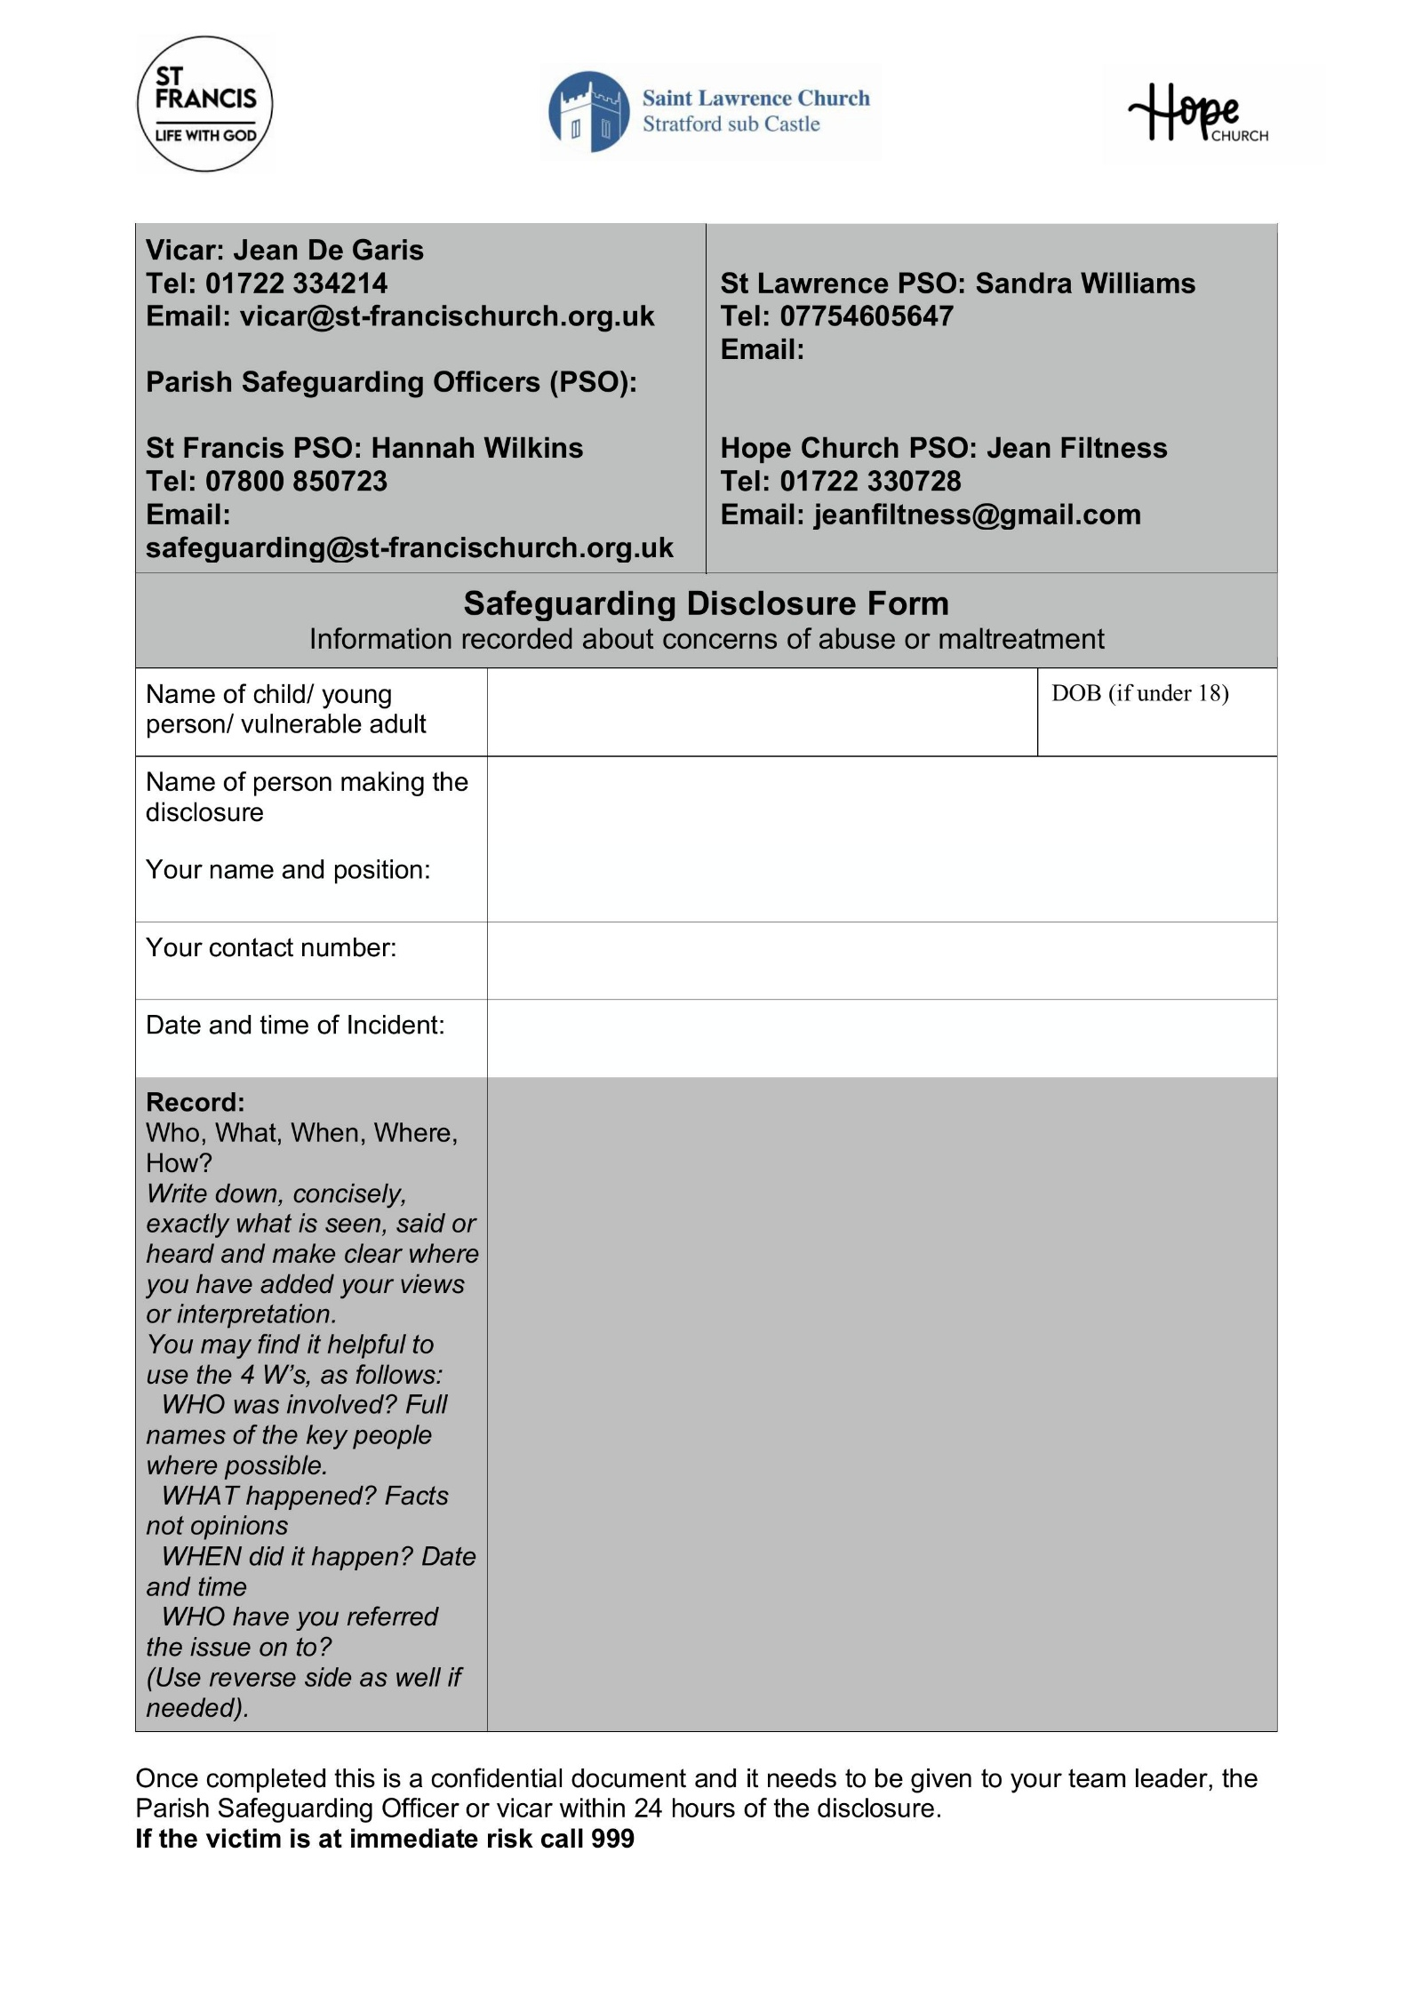
APPENDIX 1 DISCLOSURE FORM (to be used when recording a disclosure)

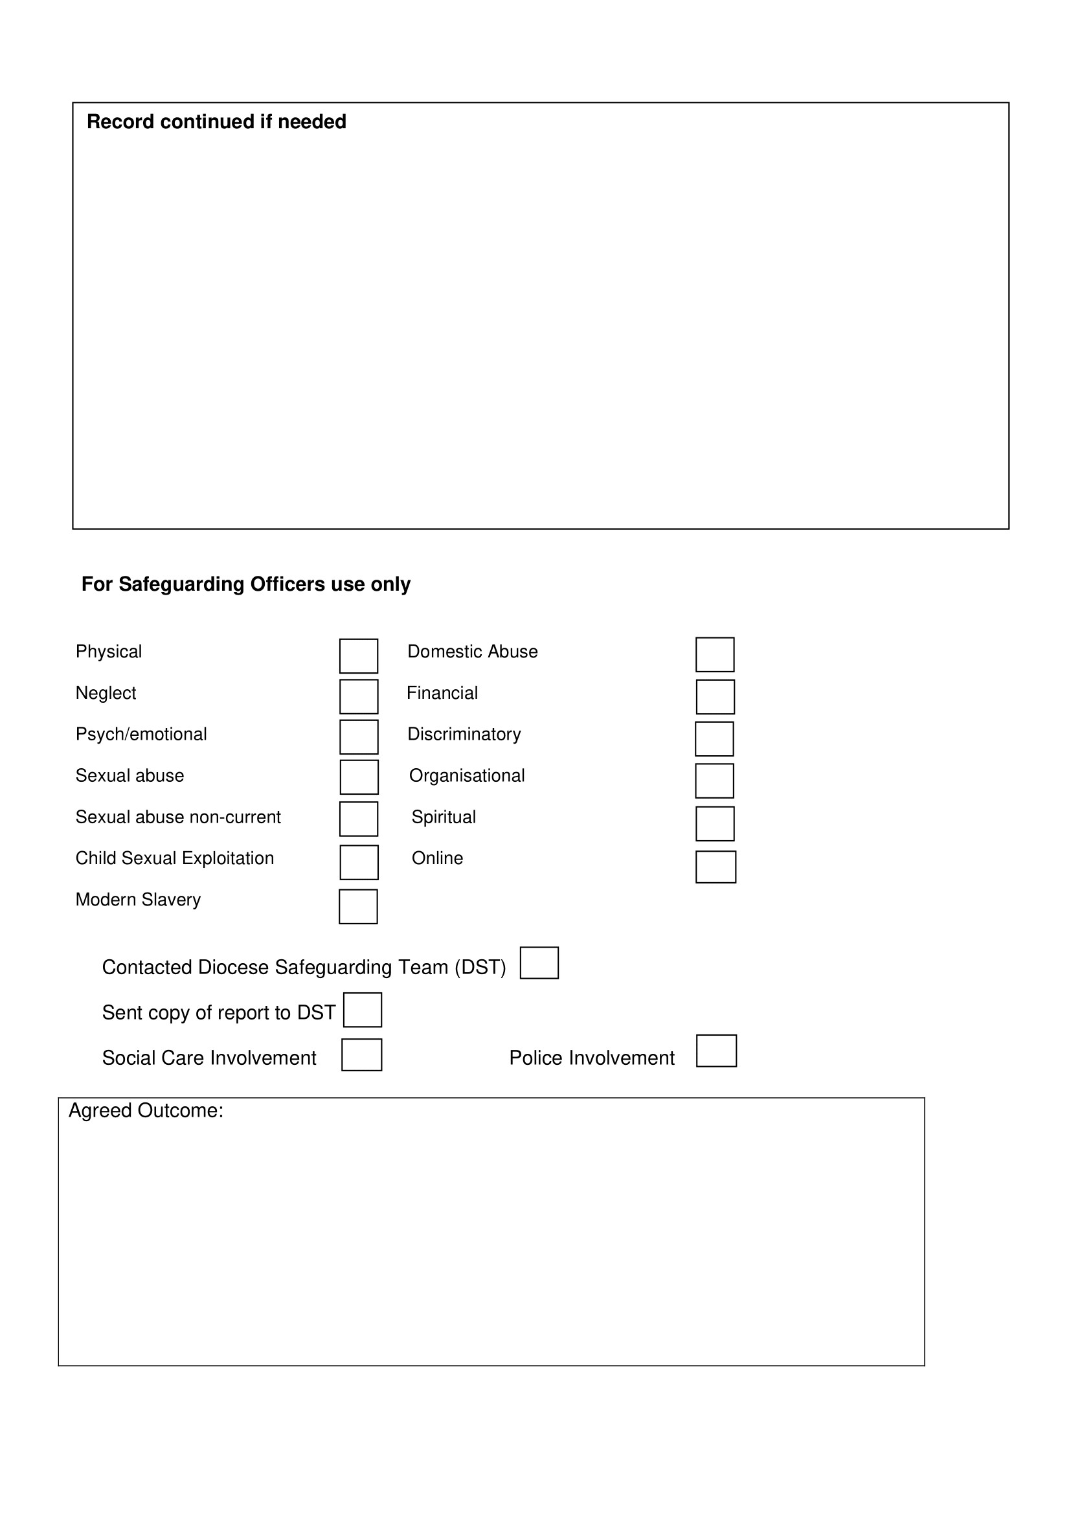

APPENDIX 2 CATEGORIES OF ABUSE OF CHILDREN AND YOUNG PEOPLE
The abuse of children and young people can take many forms. They have the same right to protection regardless of age, disability, gender reassignment, race, religion or belief, sex, or sexual orientation. Children and young people from minority ethnic groups and those with disabilities (physical, sensory and/or learning difficulties) are especially vulnerable and need special care and protection.
Where abuse occurs, it is usually perpetrated by someone known to, and trusted by, the child or young person, often a family member. The incidence of abuse by someone unknown to the child or young person is extremely low.
Statutory definitions
A full range of categories of child and adult abuse, including lists of signs to watch out for can be found in the Church of England “Safeguarding e-manual” (2021). Categories include:
Physical abuse, including hitting, shaking, throwing, poisoning, burning or scalding, drowning or suffocating. Physical abuse may also be caused when a parent or carer feigns the symptoms of, or deliberately causes ill health to, a child they are looking after.
Emotional abuse, including conveying to a child that they are inadequate, humiliation, blaming, controlling, intimidation, verbal abuse, isolation, seeing or hearing the ill-treatment of another. It may involve serious bullying (including cyberbullying). All other forms of abuse also include some emotional abuse.
Sexual abuse. This can be defined as “forcing or enticing a child or young person to take part in sexual activities, not necessarily involving a high level of violence, whether or not the child is aware of what is happening”. It may or may not involve physical contact. Examples include assault by penetration (e.g. rape or oral sex) and non-penetrative acts such as masturbation, kissing, rubbing and touching outside of clothing. It may include involving children in looking at, or in the production of, sexual images, watching sexual activities, or grooming a child in preparation for abuse. Sexual abuse can take place online and technology can be used to facilitate online abuse. Sexual abuse is not solely perpetrated by adult males. Women can also commit acts of sexual abuse – as can other children.
Neglect. Neglect can be a lot of different things, which can male it hard to spot. There are 4 main types of neglect:
- Failure to meet a child’s basic needs, such as food, clothing or shelter, and/or failure to provide adequate supervision to keep a child safe.
- Educational neglect, where a parent does not ensure that their child is given an education.
- Emotional neglect where a child is not given the nurture and stimulation they need, which could be through ignoring, humiliating, intimidating or isolating them.
- Medical neglect where a child is not given proper health care. This includes dental care and refusing or ignoring medical recommendations.

Neglect may also occur during pregnancy, as a result of maternal substance abuse.

Other forms of abuse

Domestic abuse
Domestic abuse is any kind of controlling, bullying, threatening or violent behaviour between people in a relationship and it can seriously harm children and young people who witness it. It can take place inside and outside the home, over the phone, on the internet and on social networking sites. Both males and females can be abused or abusers.

Child Sexual Exploitation
Child Sexual Exploitation (CSE) is a type of sexual abuse. Children or young people may be tricked into believing they are in a loving, consensual relationship. They might be invited to parties and given drugs and alcohol. Some children and young people are trafficked into or within the UK for the purpose of sexual exploitation.
Child sexual exploitation does not always involve physical contact: children and young people may also be groomed and exploited online. When a child/young person is sexually exploited online they may be persuaded or forced to send or post sexually explicit images of themselves, film or stream sexual activities and/or have sexual conversations. Once an abuser has images, videos or copies of conversations, they may share them with others online and use them to force a young person to take part in other sexual activity.

Child exploitation (Criminal)
This occurs when an individual or group takes advantage of an imbalance of power to coerce, control, manipulate or deceive a child or young person into criminal activity in exchange for something the victim needs or wants, for the financial or other advantage of the perpetrator or facilitator, through violence or the threat of violence (e.g. the use of “County Lines”). The victim may have been criminally exploited even if the activity appears consensual. Exploitation can take place between a child and an adult as well as between one young person and another.

Bullying and cyberbullying
Bullying is behaviour that hurts someone else – such as name calling, hitting, pushing, spreading rumours, threatening or undermining someone. It can happen anywhere – at school, at home or online. It is usually repeated over a long period of time and can hurt a child both physically and emotionally. Bullying that happens online, using social networks, games and mobile phones, is often called cyberbullying. A child can feel like there is no escape because it can happen wherever they are, at any time of day or night. Cyberbullying can include: sending threatening or abusive messages, creating or sharing embarrassing images or videos, trolling (the sending of menacing or upsetting messages on social networks, chat rooms or online games) shaming someone online, setting up hate sites or groups about a particular child, and encouraging young people to self-harm. Children are particularly vulnerable to abuse by adults who pretend to be children of similar ages when online and who try to obtain images or engineer meetings. See also the Policy for Social Media and Electronic Communication.

Female genital mutilation
Female genital mutilation (also known as “female circumcision”) is when a female’s genitals are deliberately altered or removed for non-medical reasons. It can be performed on girls of any age, including newborn infants.

THE RECOGNITION OF CHILD ABUSE
These warning signs are only a guide and not necessarily proof of abuse. If in doubt advice should be sought from the Parish Safeguarding Officer.
- Changes or regression in mood or behaviour, particularly where a child becomes withdrawn or clingy, not wanting to go home.
- Increase in aggressive behaviour /bullying others
- Nervousness / watchfulness
- Sudden underachievement or lack of concentration
- Change or inappropriate relationships with peers and/or adults
- Attention-seeking behaviour
- Persistent tiredness
- Running away/stealing/lying

Areas which may give rise to a greater level of concern:
- Any injuries not consistent with the explanation given for them
- Injuries where different explanations are given by carers or the child
- Injuries to the body which are unusual or in unusual places, not those which are usually caused by falls or playing rough games.
- Injuries which aren’t in keeping with the developmental age of the child
- Injuries or illnesses which have not received medical attention
- Unusual reluctance to remove clothing
- Any signs of neglect, undernourishment or inadequate care
- Any allegations made by a child concerning abuse
- Child with an excessive pre-occupation with sexual matters and detailed knowledge of adult sexual behaviour or who regularly engages in age- inappropriate sexual behaviour
- Sexual activity through words, play or drawing
- Sexually provocative or seductive behaviour with adults
- Inappropriate bed-sharing arrangements at home
- Severe sleep disturbances with fears, phobias, vivid dreams or nightmares
These signs may not mean that abuse has taken place, but they should make us stop and think, consider the possibilities of abuse and whether advice needs to be sought.

CATEGORIES OF ADULT ABUSE
The Church of England “Safeguarding E-manual” (2021) categorises and defines adult abuse in terms of:
Physical abuse, including hitting, slapping, pushing, kicking, misuse of medication, restraint or inappropriate sanctions.
Sexual abuse, including rape and sexual assault or sexual acts to which the vulnerable adult has not consented or could not consent or was pressurised into consenting.
Psychological abuse, including emotional abuse, threats of harm or abandonment, deprivation of contact, humiliation, blaming, controlling, intimidation, coercion, harassment, verbal abuse, cyberbullying, isolation or withdrawal from services or supportive networks.
Financial or material abuse, including theft, fraud, internet scamming, pressure in connection with wills, property or inheritance or financial transactions, or the misuse or misappropriation of property, possessions or benefits.
Neglect or acts of omission, including ignoring medical or physical care needs, failure to provide access to appropriate health, social care or educational services, the withholding of the necessities of life, such as medication, adequate nutrition and heating.
Discriminatory abuse, including racist or sexist remarks, derogatory remarks based on a person’s disability, and other forms of harassment, slurs or similar treatment. Sometimes a person may appear to be excluded from activities or groups for discriminatory reasons.
Domestic abuse, that is usually a systematic, repeated and escalating pattern of behaviour, by which the abuser seeks to control, limit and humiliate, often behind closed doors.
Organisational abuse, including neglect and poor care practice within an institution or specific care setting such as a hospital or care home. This may range from one-off incidents to ongoing ill-treatment. It can be through neglect or poor professional practice as a result of the structure, policies, processes and practices within an organisation.
Modern slavery, including human trafficking; forced labour and domestic servitude; and traffickers and slave masters using whatever means they have at their disposal to coerce, deceive and force individuals into a life of abuse, servitude and inhumane treatment.
Extremism and Radicalisation
Radicalisation is the process through which a person comes to support, or be involved in, extremist ideologies. It can result in the person being drawn into terrorism and is, in itself, a form of harm. Extremism goes beyond terrorism and includes people who target the vulnerable- including the young- by seeking to sow division between communities on the basis of race, faith or denomination; justify discrimination towards women and girls; persuade others that minorities are inferior or argue against the primacy of democracy and the rule of law in our society.
Female genital mutilation
Female genital mutilation (also known as “female circumcision”) is when a female’s genitals are deliberately altered or removed for non-medical reasons. It can be performed on girls of any age, including newborn infants.

Spiritual abuse
Spiritual abuse is a form of emotional and psychological abuse. It is characterised by a systematic pattern of coercive controlling behaviour in a religious context. Spiritual abuse can have a deeply damaging impact on those who experience it. It may include:
- Manipulation and exploitation
- Enforced accountability
- Requirements for secrecy and silence
- Coercion to conform
- Exercising control through using sacred texts or teaching
- Requirement of obedience to the abuser
- The suggestion that the abuser has a “divine” position
- Isolation as a means of punishment
- Superiority and elitism
Spiritual abuse may occur on its own, or alongside other forms of abuse, such as physical or sexual abuse. It may be used to “legitimise” or facilitate other forms of abuse.
ThirtyOne:Eight provides a helpful definition as follows:
“Spiritual abuse is linked with other forms of abuse, and could be defined as an abuse of power, often done in the name of God or religion, which involves manipulating or coercing someone into thinking, saying or doing things without respecting their right to choose for themselves. Some indicators of spiritual abuse might be a leader who is intimidating and imposes his/her will on other people, perhaps threatening dire consequences or the wrath of God if disobeyed. He or she may say that God has revealed certain things to them and so they know what is right. Those under their leadership are fearful to challenge or disagree, believing they will lose the leader's (or more seriously God's) acceptance and approval”.

APPENDIX 3 USEFUL CONTACT DETAILS IF ABUSE IS SUSPECTED

Role | Name | Telephone | Email
Vicar of St.  Francis | Rev. Jean de Garis | 01722 334214 | vicar@st-francischurch.org.uk
Parish  Safeguarding  Officer (PSO)  St. Francis | Hannah Wilkins | 07800 850723 | safeguarding@st-  francischurch.org.uk
Parish  Safeguarding  Officer (PSO)  Hope Church | Jean  Filtness | 01722 330728 | jeanfiltness@gmail.com
Parish  Safeguarding  Officer (PSO)  St Lawrence  Church | Sandra  Williams | 07754605647
Wiltshire  Multi-Agency  Safeguarding  Hub (MASH) |  | Daytime  03004560108 Out of Hours  03004560100
Diocesan  Safeguarding  Advisory Team (DST) |  | 01722 438651 | safeguarding@salisbury.anglican.org

HELPLINES FOR FURTHER SUPPORT

Safe Spaces is for anyone who feels they have experienced church related abuse of any form in England and Wales. Safe Spaces comprises a team of trained support advocates who have undergone specialist training in supporting survivors of sexual violence and who have received specific training in how the churches respond to abuse cases, the way in which faith and church-related settings have been used to carry out abuse, and the issues affecting people who have had or still have a relationship with the church. The Safe Spaces team can be contacted by:
Tel: 0300 303 1056
E-mail: safespaces@firstlight.org.uk
Website: https://www.safespacesenglandandwales.org.uk
Opening times : Monday to Friday 9am – 9pm. Saturday 9am-1pm, Sunday 1-5pm (answerphone available outside of opening times)

NSPCC |  | 0808 800 5000 For adults concerned about a child
Childline |  | 0800 1111  For children and young people
Action on  Elder Abuse  Helpline |  | 0808 808 8141
Domestic  Violence  Helpline |  | 0808 2000 247
NAPAC  Offer support and advice to adult survivors of childhood abuse |  | 0808 801 0331
Cruse  Bereavement  Helpline |  | 0808 808 1677
Modern  Slavery  Helpline |  | 08000 121 700 | Modern Slavery Helpline
Thirtyoneeight Advice and guidance on reporting concerns |  |  | https://thirtyoneeight.org

APPENDIX 4 GUIDELINES FOR RESPONDING TO A PERSON DISCLOSING ABUSE
A. Respond:
Do:
- Listen.
- Take what is said seriously.
- Only use open questions (open questions begin with words like: who, what, when, where and how. Open questions cannot be answered with a ‘yes’ or ‘no’).
- Remain calm.
- Take into account the person’s age and level of understanding.
- Check, if face to face, whether they mind you taking notes while they talk so you can make sure you capture the information accurately. At the end you can check with them that you have understood everything correctly.
- Offer reassurance that disclosing is the right thing to do.
- Establish only as much information as is needed to be able to tell your activity leader/ Parish Safeguarding Officer/ DST and statutory authorities what is believed to have happened, when and where.
- Check what the person hopes to happen as a result of the disclosure.
- Tell the child or adult what you are going to do next.
Do not:
- Make promises that cannot be kept (e.g. that you won’t share the information).
- Make assumptions or offer alternative explanations.
- Investigate.
- Contact the person about whom allegations have been made.
- Do a physical or medical examination.

  - Record

- Make some very brief notes at the time, if appropriate, and write them up in detail as soon as possible.
- Do not destroy your original notes in case they are required by the DST or the statutory authorities.
- Record the date, time, place and actual words used, including any swear words or slang.
- Record facts and observable things, not your interpretations or assumptions.
- Don’t speculate or jump to conclusions.

  - Report

- If there is immediate danger to a child or adult contact the police.
- Otherwise report to your activity leader/Parish Safeguarding Officer/Vicar immediately.
- Within 24 hours the PSO/Vicar should report the concerns to the DST.
- The DSA will advise regarding reporting to statutory agencies within 24 hours.
- If there is any doubt, seek advice from Children’s/Adult's Social Care.

